Functional Requirement Document





# Background

To book the doctor’s appointment and maintain the patient’s schedule is the key factor. A complete health app - to book doctor appointments at clinics and hospitals, set medicine reminders, consult doctors online, manage digital health records & read health tips!

# Workflow

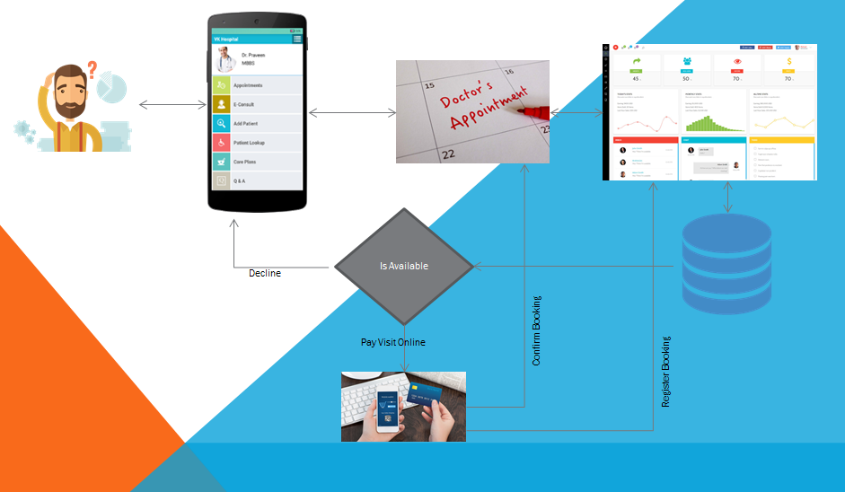

# Mobile App

1. There will a splash screen
2. There will be basic informative screens about the feature, FAQs
3. Search clinics, hospitals or Doctors by speciality and near by
4. After that A Login Page will appear
5. If user is first time, user will register his/her profile and his/her dependents
6. User can add/update his/her profile and their dependents
7. Then at the home page
   1. User can see the Departments (Specialization)
   2. After selecting the Department, it will take them to the list of Hospital Page
   3. Hospital Name will appear based on Rating
   4. Hospital Name along with the distance from the current location, Rating and Number of Doctors for that department
   5. After clicking the Hospital, it will take them to Doctor Listing Page
   6. Doctor Listing along with Rating and Availability icon
   7. Once selecting a doctor, it will ask for choose a time slot
   8. Once selecting slot, it will ask for Payment
   9. After successful payment, it will generate a token number
   10. If visit need to be cancelled, the amount will get refund to the Patient’s wallet
   11. If visit need to be reschedule then Patient can change the time slot based on availability else can cancel for that day.
   12. Patient can use their wallet balance for any further appointment booking for any clinic/hospital, any doctor.
   13. If visit is done, it will ask for give the feedback and rating about the doctor
   14. User anytime can download his/her doctor consultation fee receipt
   15. There is a separate dashboard for every visit, which will contain
       * Prescription Details
       * Health digital record

**Admin Desk**

This admin panel will be in Software as a Service (SAAS) model. There will a Super Admin, who will be having entire control of the system. Every Clinic/Hospital would be giving a site admin privilege to operate its own appointment and turn over.

Super Admin will create a profile for specific Clinic/Hospital.

* Create Profile with Images, Address, Contact No and Brief about the Clinic/Hospital
* Create Bank Details for transaction
* Clinic/Hospital Turn Over (Day/Month/Year)
* Maintain Margin %
* All Master data forms
* Mobile and public site advertisement management
* All Clinics/Hospital individual pages management

Site Admin, will create its own

* Login for Clinic/Hospital Admin
* Add/update content, more details on his/her clinic/hospital page
* Doctor’s profile (Name, Degree, Reg. No, Image etc.)
* Doctor Credential
* Doctor’s Visiting Hours
* Clinic/Hospital staff profile creation with credential and his/her role in clinic/hospital
* Day End/Month End/Year End Sales Journal (Report)
* Patient Database
* Notification management

Site Admin Operation:

* Login for Clinic/Hospital Staff
* Verify the token number

Doctor Operation:

* Confirm the visit
* Create/Modify the Prescription
* Suggestions
* Close Visit
* Doctors feedback and Rating approval

Patient Desk

|  |  |
| --- | --- |
| Scopes | Information |
| Registration | * Mobile No * * Email ID * * Password * * Confirm Password * * Address (pick up current location) * * OTP * |
| My Profile | * Own Profile   + Gender   + Height   + Weight   + Date of Birth   + Blood Group   + Blood Pressure   + Any Disease   + My Pic   + Health Record (max 5 and less than 2MB in total) * Family Profile (Multiple)   + Relationship   + Gender   + Height   + Weight   + Date of Birth   + Blood Group   + Blood Pressure   + Any Other Disease   + Pic   + Health Record (max 5 and less than 2MB in total) |
| My Visits | * Clinic/Hospital Name * Doctor Name * My Prescription * Date and Time of Visit * Test Report (max 5 and less than 2MB in total) |
| Rating/Feedback | * Select Visit * Rate the Doctor * Feedback about the Doctor * Recommend Doctor through Social Media (Facebook, Google+) |
| Book Appointment | * Select Hospital/Clinic * Select Doctor * Select Date and Time * Pay Visit (by Card/PayTm/Wallet) * Generate Token * Send Notification * Reschedule * Cancellation |

Doctor Desk

|  |  |
| --- | --- |
| Scopes | Information |
| Registration (by Clinic/Hospital Admin) | * Login ID * * Email ID * * Clinic Name * * Mobile No * * OTP (send to Mobile) * New Password * (by Doctor) * Confirm Password * (by Doctor) |
| My Profile | * Full Name * Reg. No * Degree * Upload Pic * Other Achievement * Other Info |
| Login | * Login ID * Password * Select Clinic |
| Visits | * Select Token ID * Refer Old Diagnosis * Create Prescription (Auto suggest Medicine Name) * Suggest Test * Spot Test (update at My Profile)   + Weight   + Height   + Blood Pressure |